The interface for the prototype gives the user control over what they would want to watch, as they get to pick the movie and the time that they would want to watch it, this aligns with Nielson’s usability heuristics as one of them is to being able to give the user choice, which this prototype allows. However, there aren’t many options to choose from and there’s no way to be able to see what the upcoming movies are.

The interface is consistent as it shows all the movies and the titles at all the same size, making it so that the title is clear for the user to see and to know which movie is which. However, to meet the heuristics requirements, where it says “What’s on” is a little too small for the user to see when they enter the page, also the colour of the text to a bit too dark, which means that it would be difficult to see on the black background, so the colour of the text could be changed to a colour that is a bit brighter.

This interface for the prototype is quite efficient, as it as the shortcuts to all the other pages that the user would need access to, for example, the user can gain simple access to the orders page just by pressing the button that is on the top left of the page. One thing that we could change is to make all the button more central, this would make the page look a little cleaner and easier to navigate, as some of the buttons are on the other side of the page.

The aesthetics for the interface is quite simple, meaning that there isn’t a lot of useless clutter but instead only the important things are on the page, making sure that the user would be able to navigate the page with ease and with little-to-no issue. On the other hand, the text that is on the page is quite small, so they might have a hard time trying to find the right button press on, n

The interface for the performances allows the user to see if any mistakes have been made while booking tickets for the movie, as it has a list of all the orders they have made. The order line allows them to edit a specific order, so they can either delete it altogether if its wrong, or they can add or take away a booking if there is either not enough tickets being booked, or they have booked too many tickets and would need to take some away.

Also, because all the bookings they would make would be added to this order line, it helps them keep a neat documentation of which screen they would need to go to and the total price of each booking, giving the user total freedom in the way they would want to edit the orders, as they could just end up deciding not to watch a movie altogether and cancel the entire order, this meets the criteria for the heuristics, as this gives the user a documentation of all the orders which also allows

This is the updated version of the “What’s on?” page, the text has been made bigger and clearer, as it now a colour which better fits the darker background. The movie thumbnails have been made clearer as they have become more visible, this has made the interface more suitable and aligns more-so with the heuristics. The text aligns well with the WCAG, as we can’t just rely on colour by itself, so we had to change the size of the font so that it would appear clearer for people that need support with their vision.

Here is the updated version of the items interface, this better fits the WCAG, as it would help with the user’s vision, as if the background was a bright colour, it could be difficult for the user to see the page properly, also the text is a colour that compliments the background of the orders menu, it makes the text clear for people that could have issues with their sight.

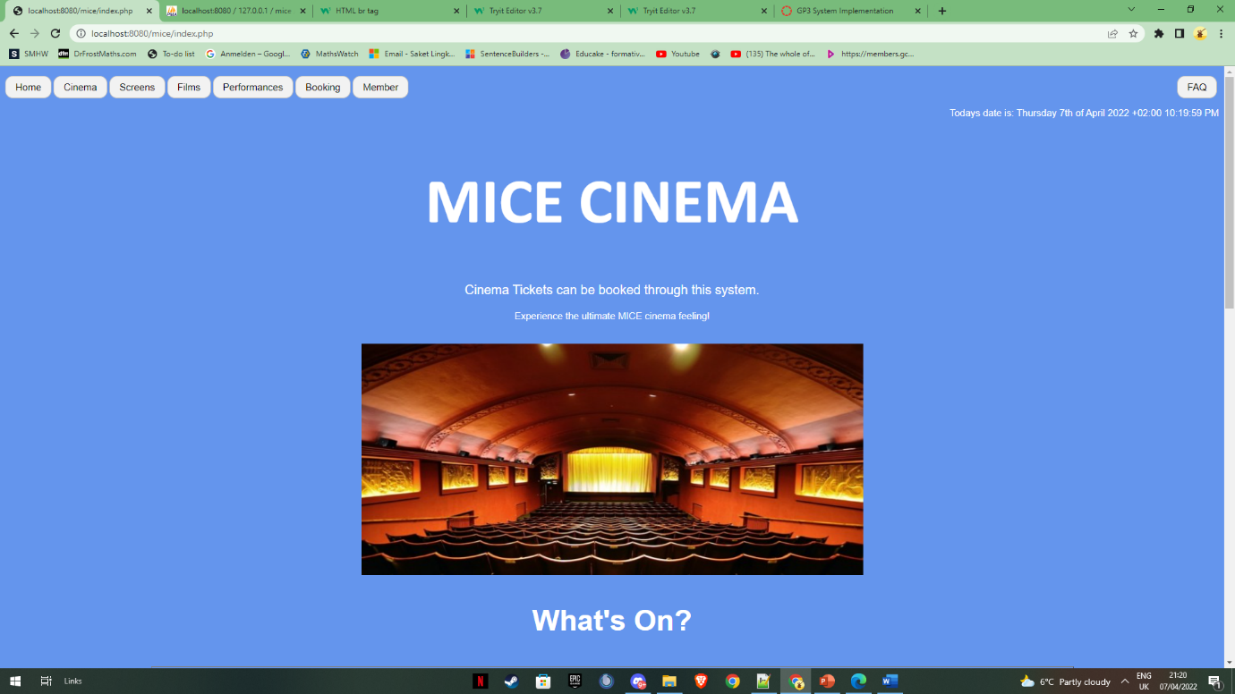

This is the improved version of the home page, this version of it works better alongside the WCAG, as it now accommodates to people that could be colour blind, as the colours that are being used for the font and background no longer blend into each other, making it clearer for people with impairments to be able to move around and navigate around the website.

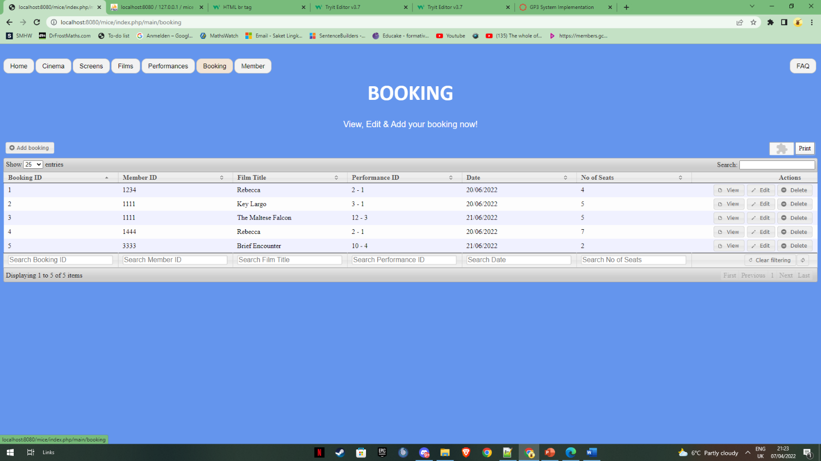

This is the updated version of the bookings page; it has been changed to have a much lighter look to it. However, the functionality of the bookings page hasn’t improved; as there are still some issues that happen when making a book, for example, when making a booking the amount of seats available don’t go down depending on how many seats have been taken.

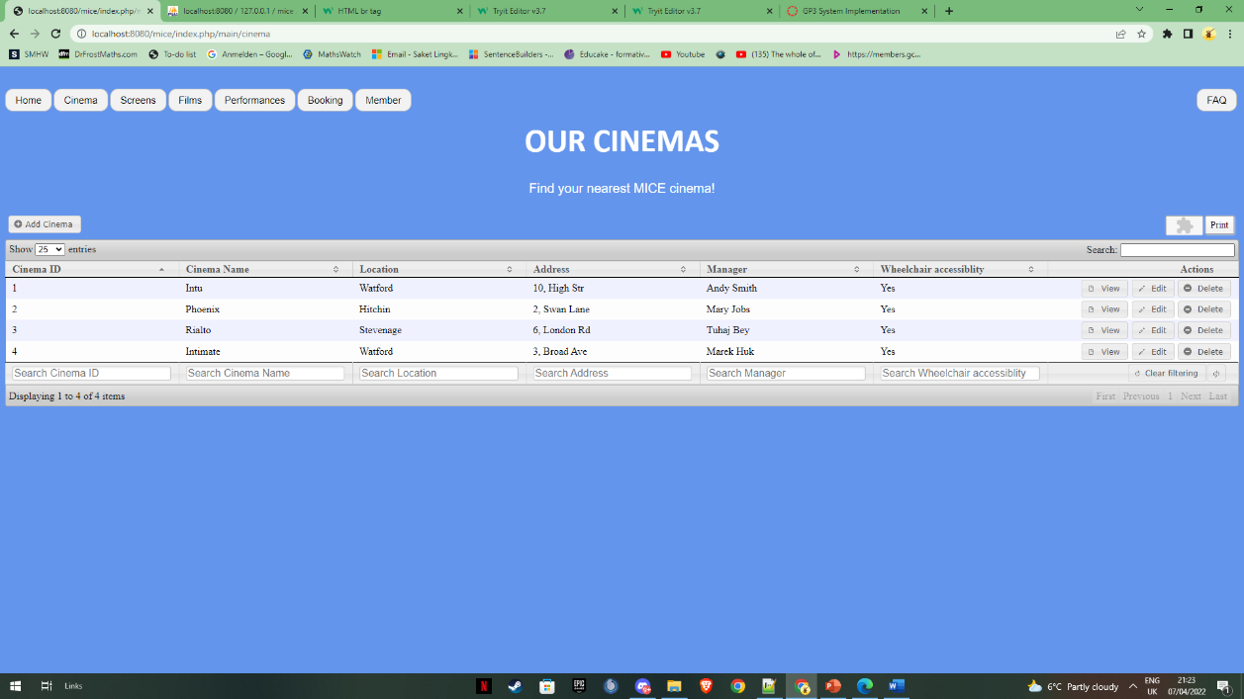

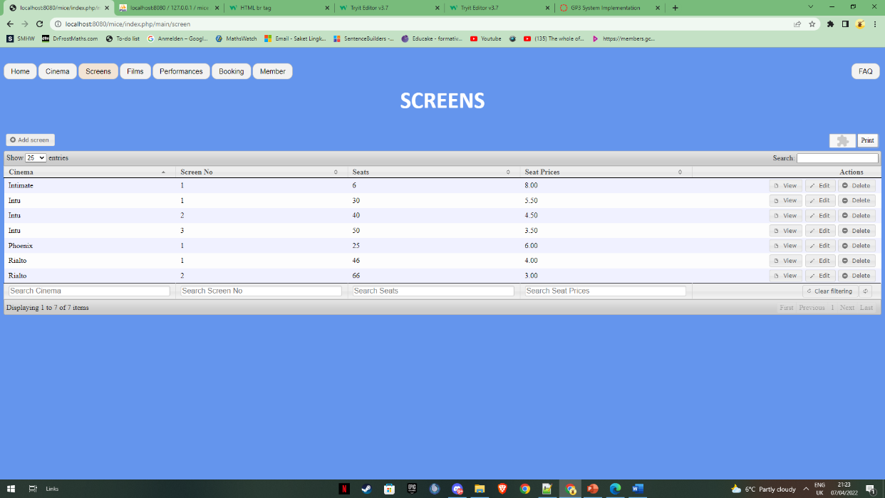

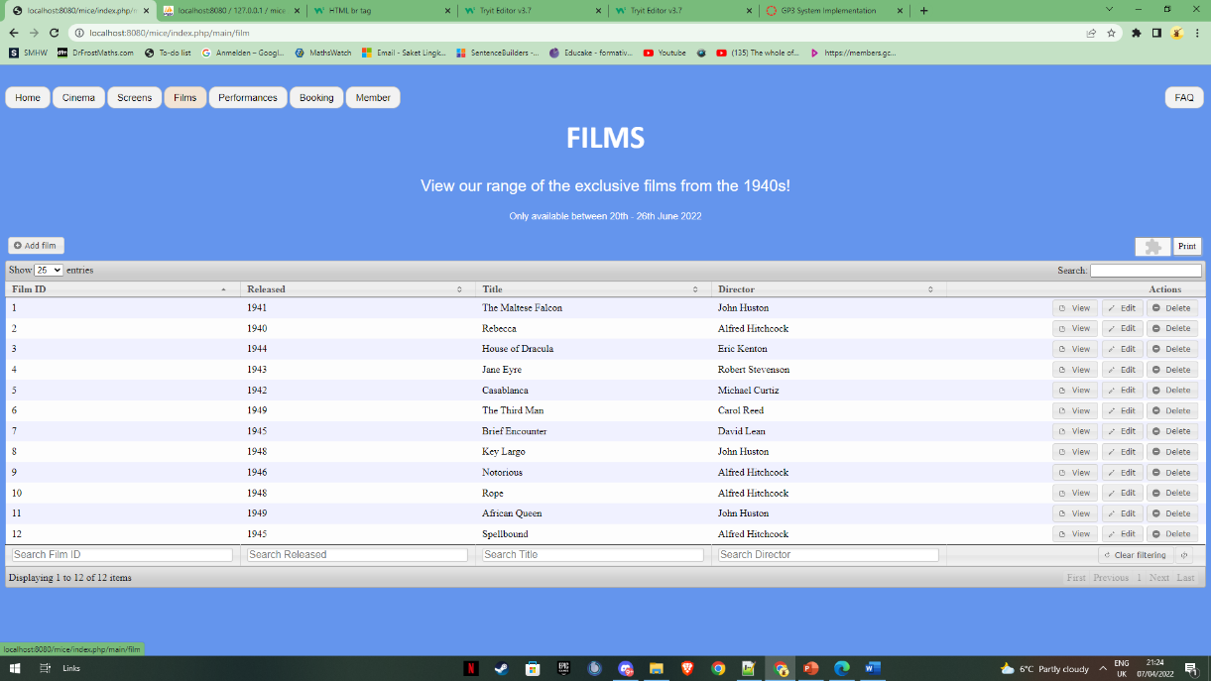

The functionality of the “our cinemas”, “screens” and “films” pages are all working as intended, this allows the pages to all work alongside Nielsen’s Usability Heuristics, as they all give the user the freedom to edit it however, they like, for example, on the “films” page, the films that being viewed would update whenever a new one is being viewed in the cinema. Another thing is that the “our cinemas” page, it gives the users all the information about the locations, such as, the address, whether the location has wheelchair access.